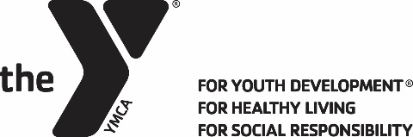

FINANCIAL ASSISTANCE APPLICATION
2018 YMCA BLUE RIDGE LEADERS’ SCHOOL

ONLY TYPED FORMS WILL BE ACCEPTED – TYPE INTO FIELDS BELOW AND PRINT
Financial assistance will be awarded to qualifying Leaders’ Division applicants based on need and available funds. Priority will be given to 1st and 2nd year enrollees. Maximum award will be $175 per person. For consideration this form must be fully completed including all four signatures. Reproduce this form as needed. APPLICATION DEADLINE: April 1. Use additional pages if necessary.
YMCA Name: |  |  | Club Advisor:
Name of Applicant: |  |  |  | Female Male |  |  | Age:
Home Address: |  | City: |  |  |  | State: |  | Zip:
Number of years in the Leaders’ Club program: |  | This is the applicant’s year at Blue Ridge Leaders’ School
Explain the need for the financial assistance:

Describe the efforts on behalf of the applicant to raise funds to attend the school:

How much has been raised? $

Is the YMCA financially assisting the applicant to attend the School? Yes No If yes please describe:

Amount provided by the YMCA? $
Advisor statement supporting need:

In the applicant’s own words, why is it important to have the Leaders’ School experience?
Total annual family income (before taxes): $ | Total people in household: |  |  |  | Number of children living at home:
My Leaders’ School application is: Already In Attached with this application

NOTE: All four signatures are required to process this application.

1. Applicant Signature Date:

2. Parent/Guardian Signature Date:

3. Club Advisor Signature Date:

4. YMCA Executive Director Signature Date:
Return by April 1 to: Brianne Pietronicco, Blue Ridge Leaders’ School, P.O. Box 989 Lake Villa, IL 60046

