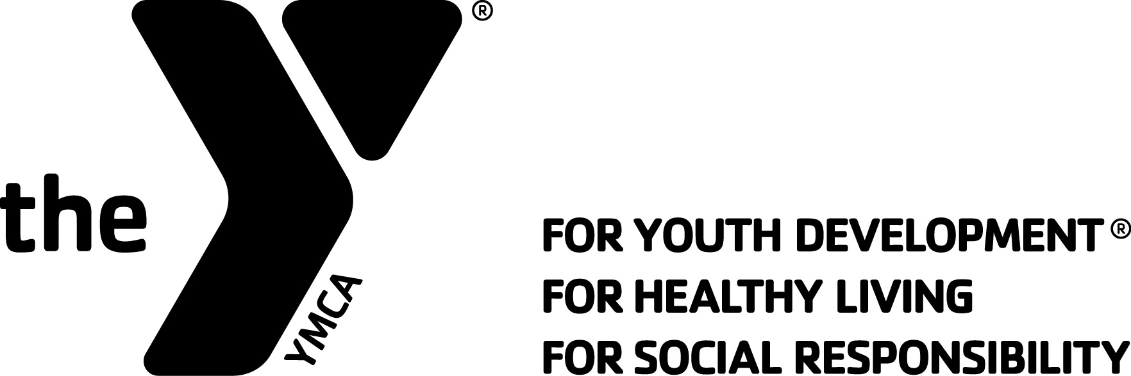

CLUB RECOGNITION APPLICATION
2018 YMCA BLUE RIDGE LEADERS’ SCHOOL

Application Deadline: Postmarked by MAY 15
YMCA/Leaders Club Name: |  |  |  |  | Date:
Address:
City: |  |  | State: | Zip:
Phone Number: | Email Address:
Club Advisor: |  | Position Title:
Applying for recognition as: Level I Level II Level III

By signing below I attest the Leaders Club named above has met all the criteria necessary in application for recognition as indicated.
Leaders Club Advisor Name: | Signature:
YMCA Executive Director Name: | Signature:
YMCA Board Chairman Name: | Signature:

LEADERS CLUB RECOGNITION CRITERIA

Written documentation CLEARLY supporting each item of criteria MUST BE INCLUDED with this application. – LABEL EACH DOCUMENT WITH THE CRITERIA NUMBER
Level I Criteria
- Written club constitution consistent with the mission and purpose of Blue Ridge Leaders’ School.
- Written proof of professional staff and/or volunteer oversight by YMCA administration.
- Written proof of documented training sessions which address improving one’s spirit, mind and body. These shall include (as facilities permit) aquatics, fitness, sports, gymnastics and the theory of YMCA leadership and service.
- Written proof of 75% of the club membership shall provide a minimum of 24 service hours annually.
- Written proof of all club members shall pass a written test to attain club membership.

Level II Criteria
- Written proof of all Level I requirements.
- Written proof of Club operating with elected and functional officers.
- Club membership shall review and approve the constitution annually and be documented by written minutes of the meeting.
- Written proof of 50% of the club membership shall provide a minimum of 100 hours of YMCA volunteer service annually.
- Written proof of Club participation in Blue Ridge Leaders’ School and one other regional Leaders Club event annually.

Level III Criteria
- Written proof of all Level II requirements.
- A written training calendar in which the curriculum includes aquatics, fitness, sports, gymnastics and the theory YMCA leadership and service.
- Written proof of 75% of the club membership shall provide a minimum of 100 hours of YMCA volunteer service annually.
- Written proof of that at least one club member participates on a standing YMCA committee or works with some type of ongoing adult group throughout the Leaders Club year.
- Written proof of the Club participating in the local YMCA annual support campaign and/or raise contributed dollars toward a YMCA scholarship fund.
- Written proof of the Club conducting a multi-YMCA training event at least once every two years.

Return this form and written labeled documentation by MAY 15 to: Ryan Graham at Brace YMCA 3127 Weddington Road, Matthews, NC 28105

